**Monitoring layer**:

1. Traditional infrastructure

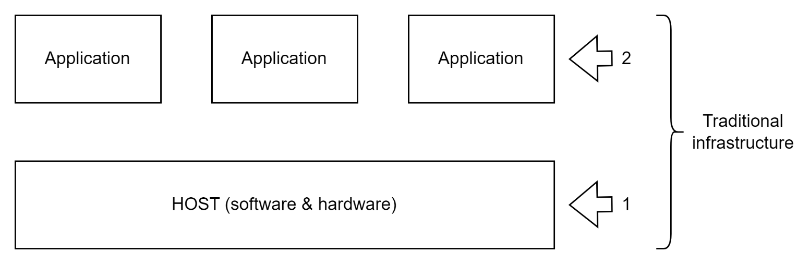

1. Containerized infrastructure

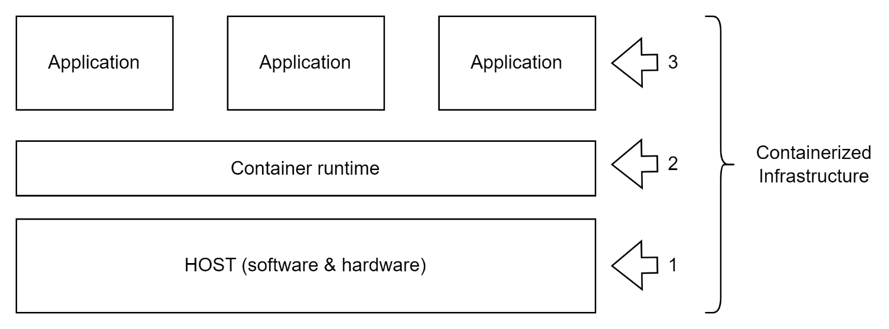

1. Orchestrated containerized infrastructure.

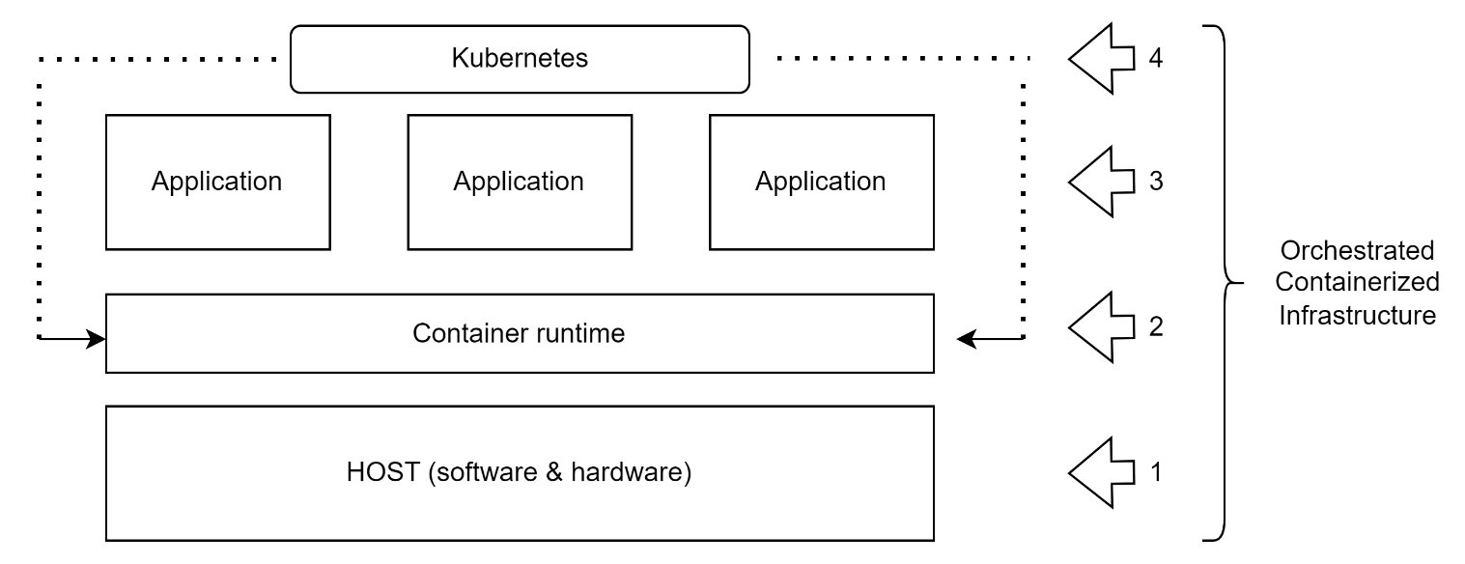

**Monitoring metrics**:

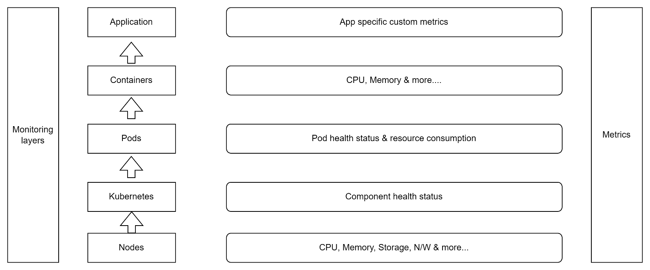

**Monitoring tools**

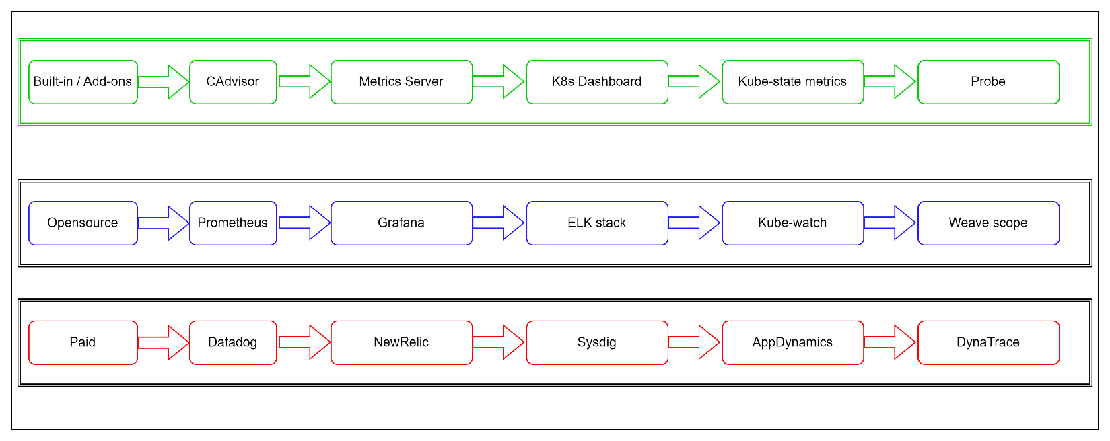

**Monitoring pipelines**

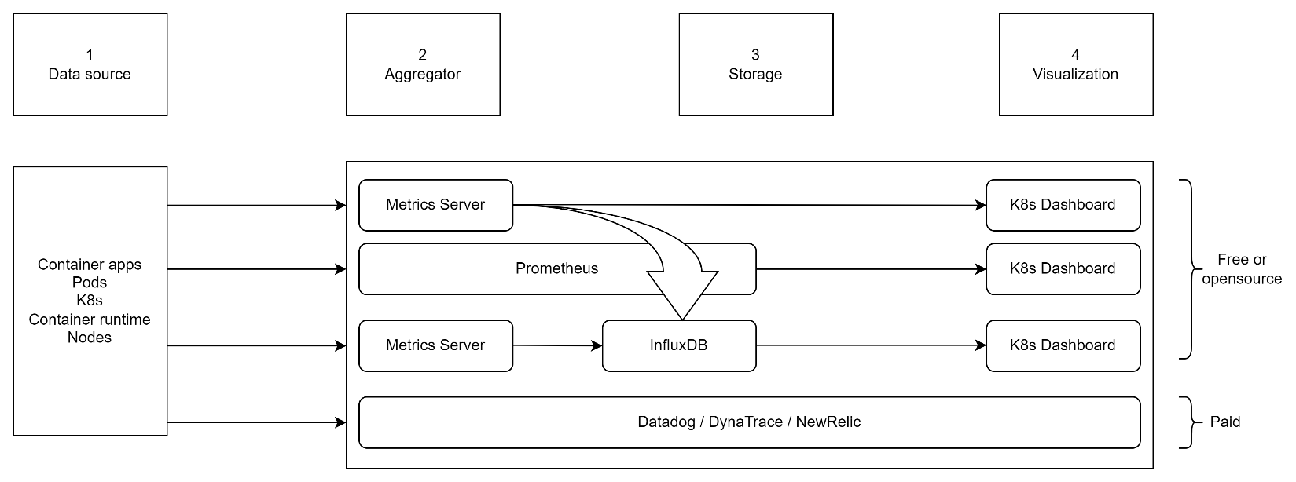

**Logging pipeline:**

